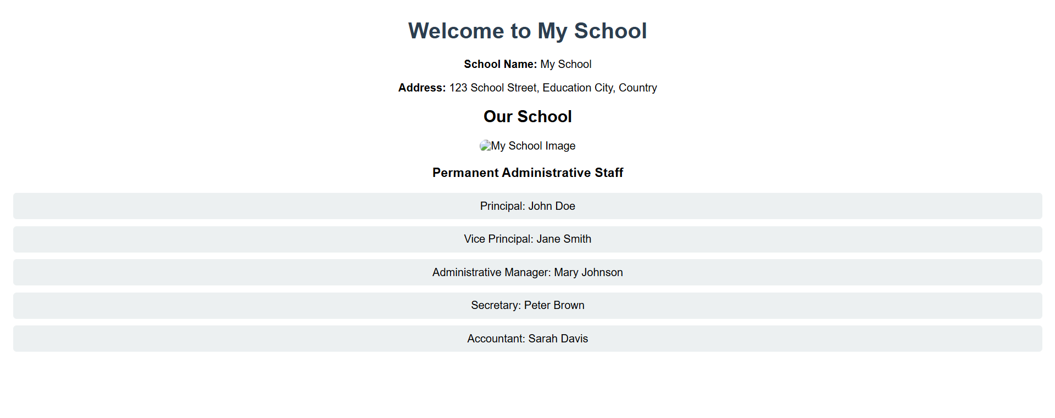In this lab, I learned how to create a simple HTML webpage that displays important information about a school, including its name, address, an image, and a list of administrative staff. I used basic HTML elements such as headings, paragraphs, lists, and images to structure the page and added some CSS for styling. I also learned how to test the webpage locally using **Live Server** in **VSCode**, which allowed me to see real-time updates as I made changes to the HTML code. Additionally, I gained hands-on experience with **Git** and **GitHub** by creating a repository, initializing Git in my local project, and pushing my code online. This lab helped me understand the process of web development, from coding the webpage to deploying it on GitHub, allowing for version control and easy sharing. Overall, this lab enhanced my understanding of front-end web development, file management, and version control using Git and GitHub, which are essential skills in modern software development.